**Ex03 – Garage Management Classes & Diagram**

**Ilan Kushnir** 203442306

**Ofir Cohen** 307921320

**Classes:**

* Vehicle: Base class for all kind of vehicles in the garage.
* Motorcycle, Car, Truck: Derived from class Vehicle. Each has unique specifications.
* VehicleCard: Each Occurrence (vehicle) in the garage is hold by a ‘VehicleCard’ object with all its specifications including his owner.
* EnergySource: Base class for both electric engine and fuel engine.
* Battery, Fuel: Derived from class ‘EnergySource’ and represent 2 different kinds of engine – Electric and Fuel.
* VehicleInputData: Holds all the user’s input data in order to create a ‘Vehicle’ object.
* VehicleCraetor: Uses a ‘VehicleInputData’ object to create a new ‘Vehicle’ object.
* Wheel: Holds wheel’s relevant information.
* UI: The user interface class – display to the console and interact with the user. Attaches the logic part of the program including the data base to the visual part.
* Program: The main class – in charge of creating a new instance of a garage and running it.

**Enums:**

* eVehicleStatus: All possible conditions of a vehicle during its stay in the garage. Contained in class ‘VehicleCard’.
* eVehicleType: The possible vehicle types taken care in the garage at the moment. Containd in calss ‘VehicleCreator’.
* eCarColor: All possible colors for a non-electric cars. Contained in class ‘Car’.
* eNumOfDoors: All possible car shapes (number of door wise) for a non-electric car. Contained in class ‘Car’.
* 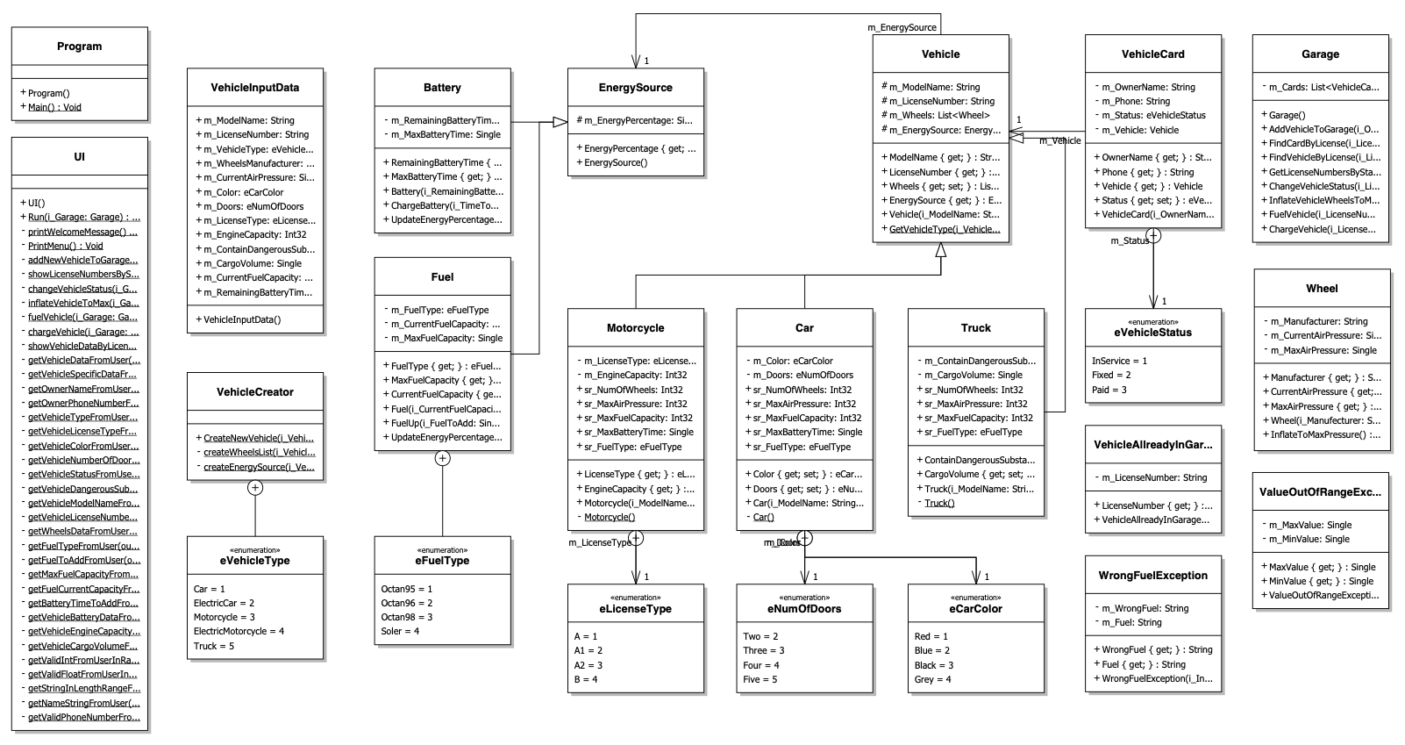eFuelType: All possible kind of fuel for fuel engines. Contained in class ‘Fuel’.